**Project report**

**Project Title:** Online Examination System and Management.

**Description:**

This is a project for making an application that helps an Instructor to create an online exam and a student to take the exam.

**Languages and Tools used:**

We have used HTML5,CSS,BOOTSRAP,JAVASCRIPT,PHP,SQL and visual studio editor.

**Functionalities:**

**Log-In:** Instructor and student will be asked to fill Username and Password field to log-In. Here we have predefined users with their credentials. You can add/modify,delete user as per your requirement because here we have implemented code for log-in page, not for sign-up page. Instructor and student’s credentials is stored in ‘info’ and ‘sinfo’ table respectively.

**DASHBOARD:** After logging-in, Instructor and student will be redirected to their dashboard page respectively. 1) From dashboard Instructor can generate exam, can see results, can logout. 2) Student can take exam, can see his/her result, can logout.

**Instructor:**

1. **Generate exam**: By clicking generate exam from dashboard Instructor will be redirected to ‘generate exam’ page. Instructor can generate exam by filling information like exam title, duration of exam, time etc. and Instructor must have different exam title every time otherwise it will not allow Instructor to generate exam of same name. By clicking GO AHEAD button exam’s information will be stored into ‘exam_desc’ table and Instructor will be redirected to the ‘add-question’ page. At add-question page, Instructor will be asked to add a question and its detail like options, correct answer, marks etc. After creating list of questions, it will be stored into the ‘add_question’ table for respective subject. Now Instructor can preview those questions by clicking PREVIEW button and will be redirected to ‘preview’ page. At preview page, list of questions will be at Instructor’s screen and Instructor can modify, delete question and its detail. Most important note: At add-question page, Instructor has to remember that for every question Instructor must click add question button and for last question Instructor has to click preview button so for last question Instructor does not have to click add question button, by simply clicking preview button last question of Instructor ‘s exam will be stored into the add-question table. For example, Instructor wants to add 10 questions in their exam so Instructor needs to write question, options etc. field and has to click ADD QUESTION button, this process must follow by Instructor 9 times and for 10th question Instructor has to click PREVIEW button instead of ADD QUESTION. At Preview page, Instructor has to click on CREATE EXAM BUTTON and exam will be stored into the database.
2. **Results**: Instructor can see the list of exam which he/she had created and by clicking one of the exam title Instructor can see the results of student who have appeared in the exam.
3. **Log-out:** From dashboard Instructor can log-out.

**Student:**

1. **Take exam:** Here student can see list of exam and its starting time, subject name etc. Student can click on exam title and can take exam if it has started. We have added auto-submit feature. Student needs to submit exam before deadline, otherwise it will get submit, automatically. Marks will get evaluated and total marks will be shown to student at next page, immediately. Exam will be shown to students according to their respective academic year(ac_year).
2. **See results**: Student can see his/her result for which he/she has appeared.
3. **Logout**: From dashboard student can logout.

**DATABASE:**

1. add_question: This table stores question and its detail for respective exam. Instructor will add question into it at add-question page.

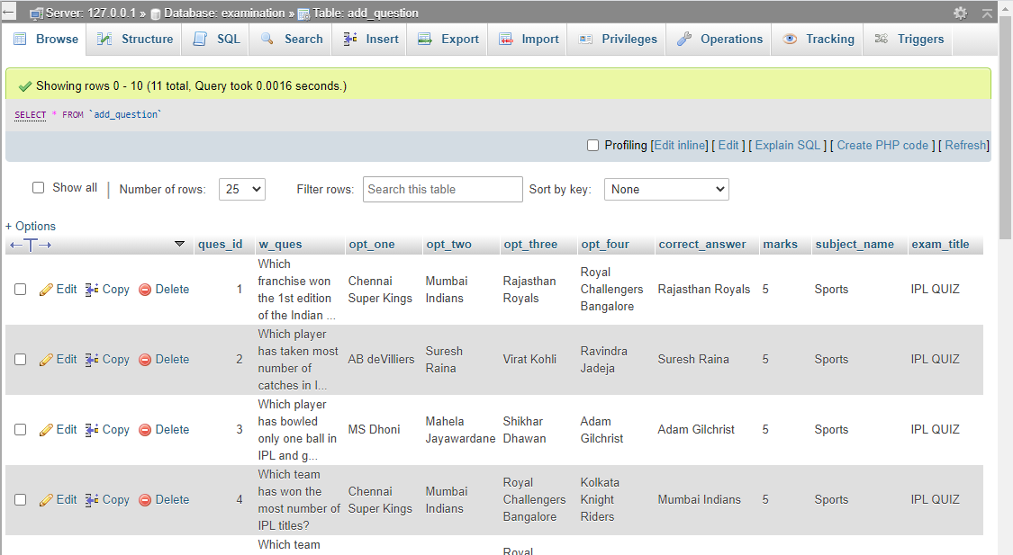

1. exam_desc: This table stores exam title and its details. Instructor will add exam description at generate-exam page.

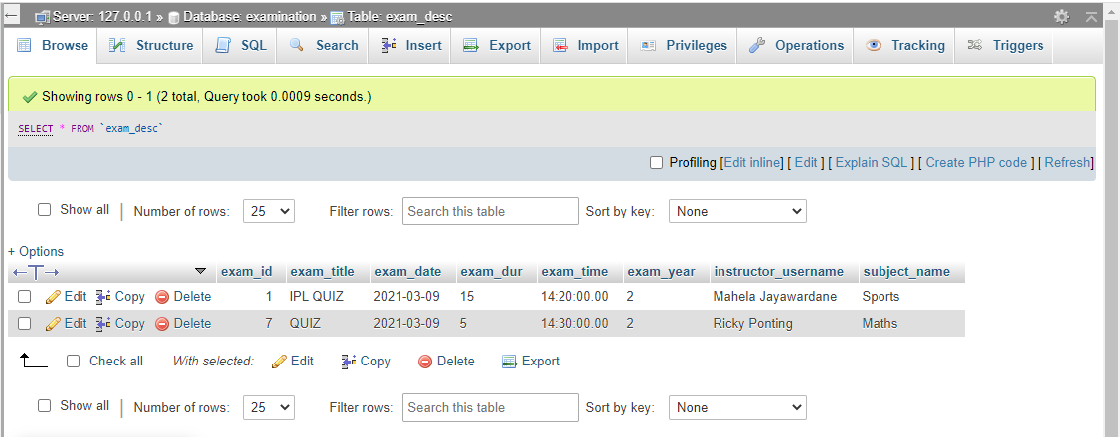

1. info: stores the credentials of Instructor.

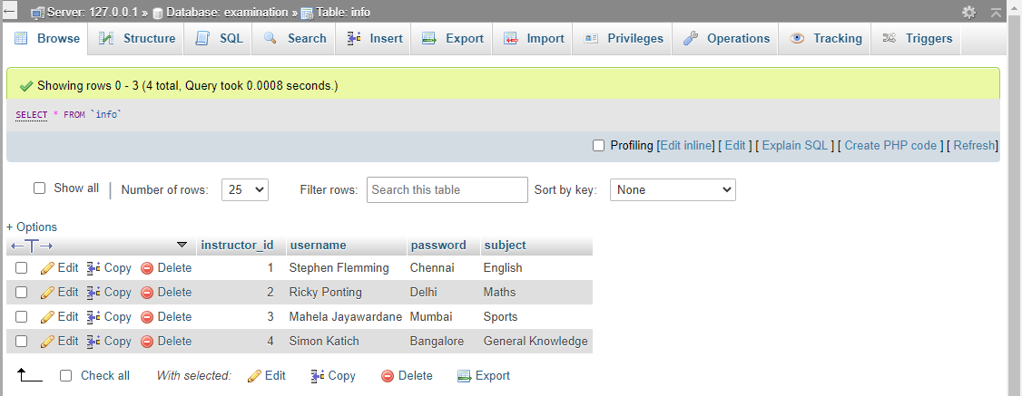

1. sinfo: stores the credentials of students.

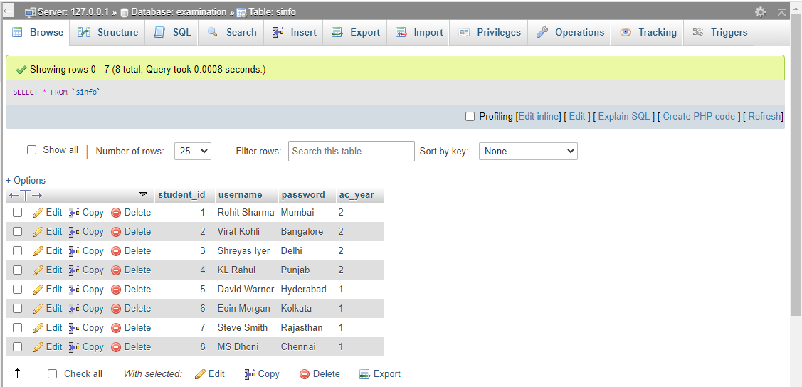

1. result: stores the results of students. Instructor and student can see the result.

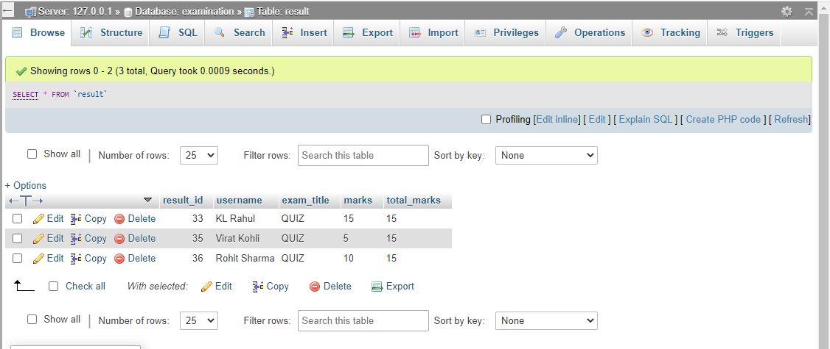

**Snapshots of the Project:**

1. This is the first page in our application in which an instructor or a student can log-in respectively.

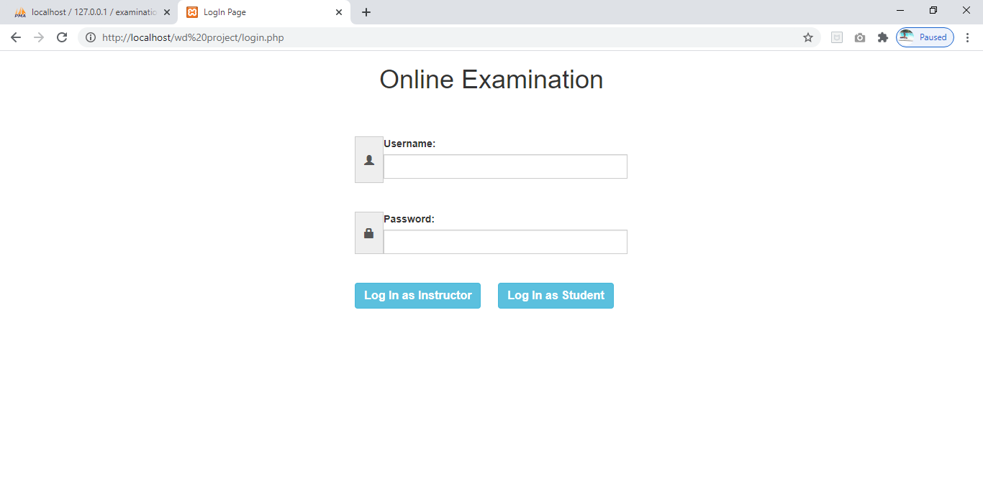

2. If a user enters invalid username or password, the error line appears in red color as shown below. On successful log-in, the user is directed to the respective dashboard page.

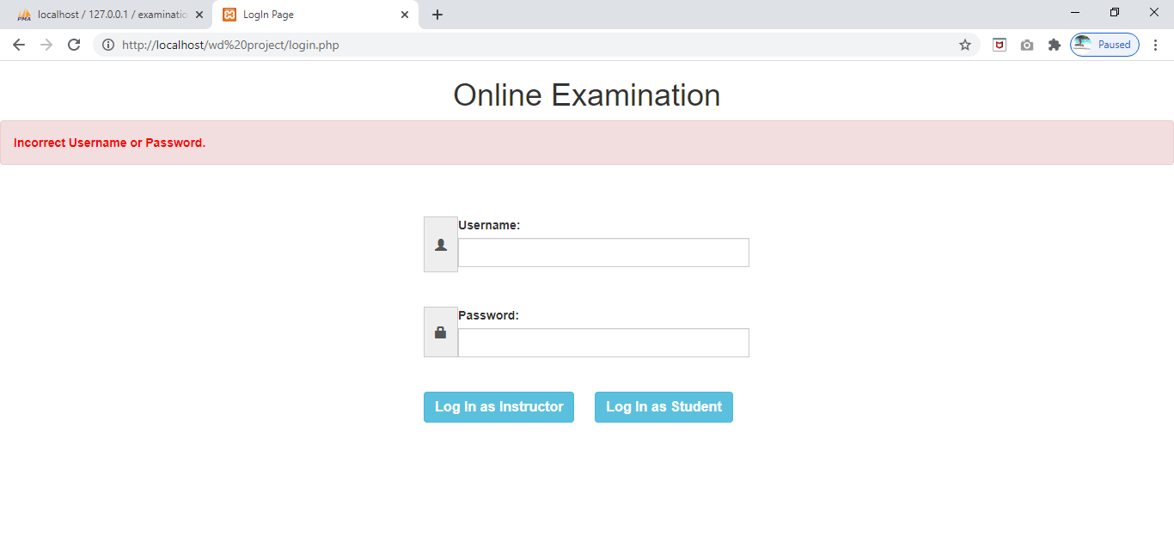

3. This is the instructor’s dashboard consisting of three different options:-

i. Generate Exam

ii. View Result

iii. Logout

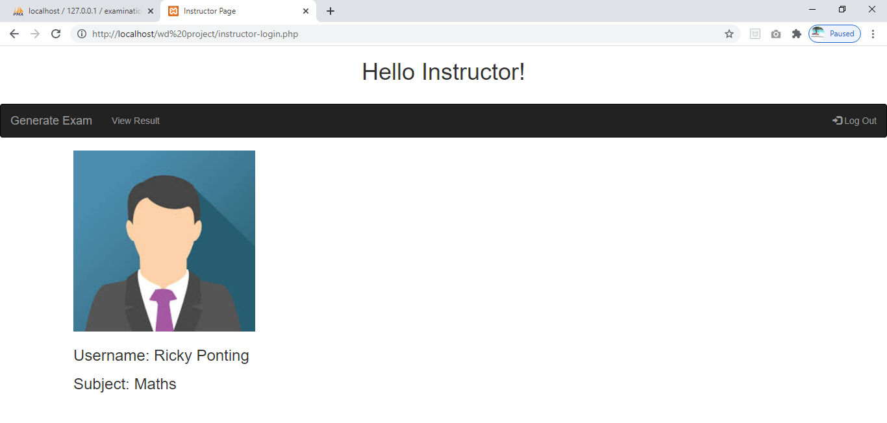

4. When user clicks on ‘Generate Exam’, he is asked to submit the exam description with a title that has not been used earlier.

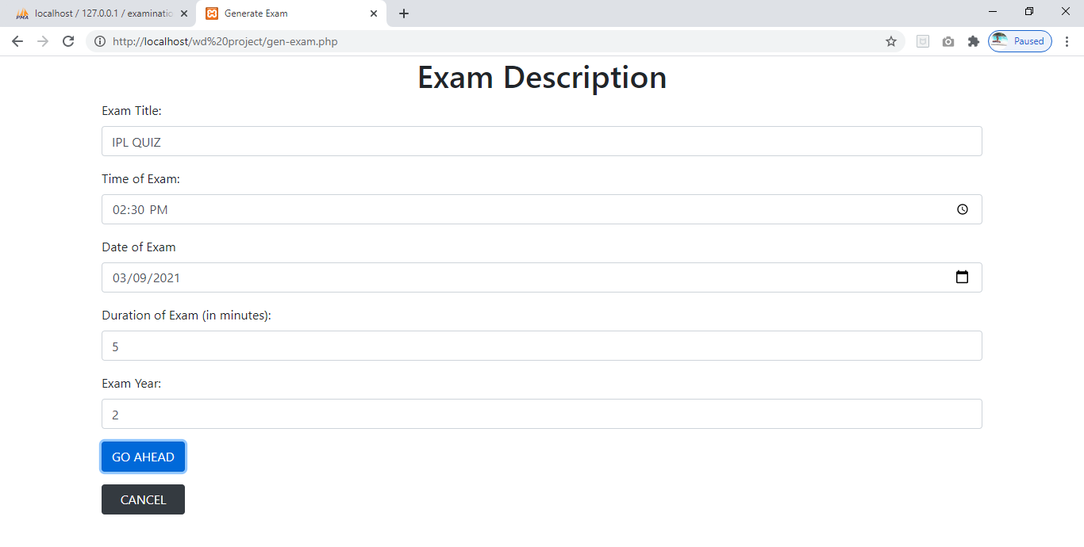

5. If the title entered is already used earlier, the exam is not created and an error message is displayed.

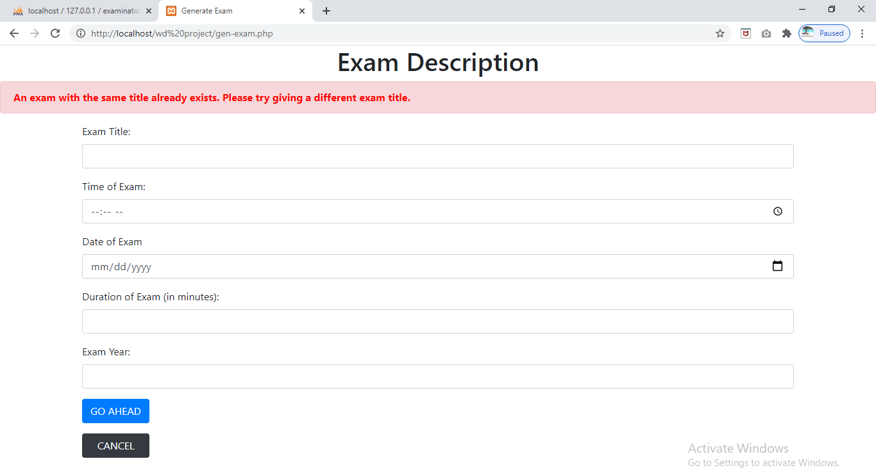

6. On successful exam creation, the instructor is asked to enter the questions. Instructor can add more questions by clicking the ‘ADD’ button. When instructor is done writing the last question, he has to click ‘PREVIEW EXAM’ in order to have a look at all the questions entered and also update/delete them.

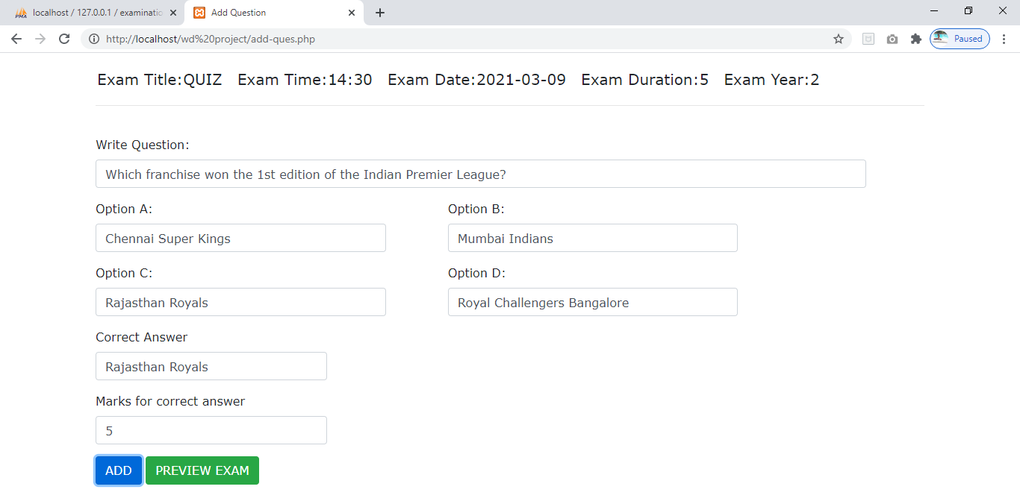

7. This is the preview of all the entered questions which can further be updated, deleted or kept as it is.

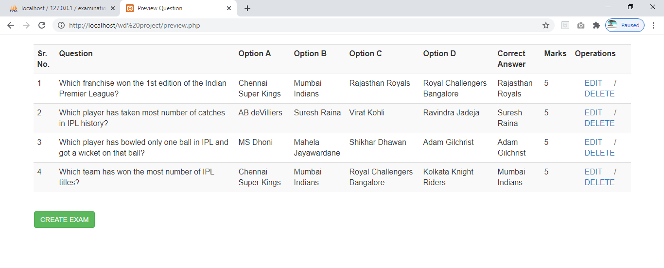

8. Instructor can edit a particular question by clicking the ‘EDIT’ button in the respective row. Editing a question is just submitting a form with the updated information.

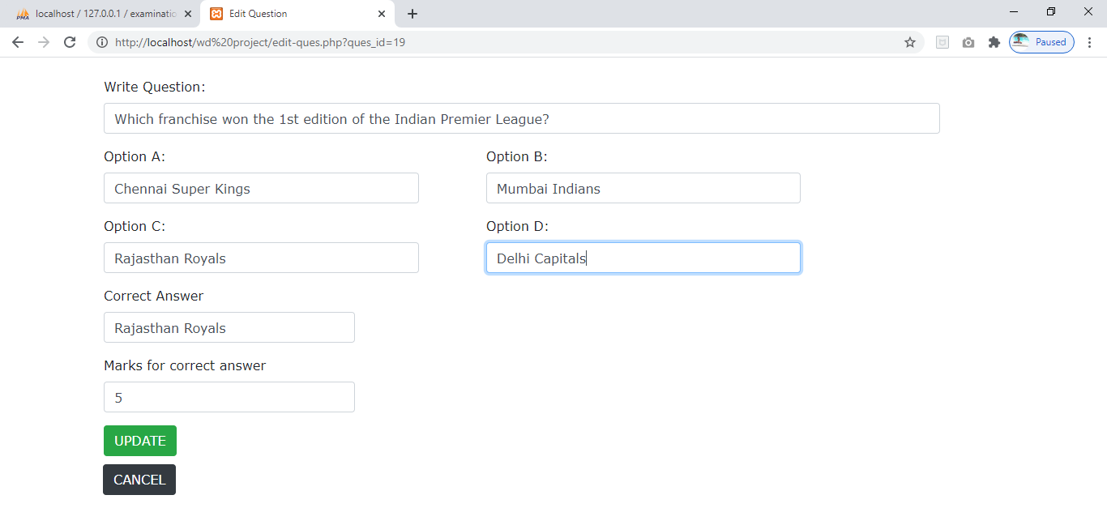

9. When a question is updated successfully, the success message is displayed as shown below.

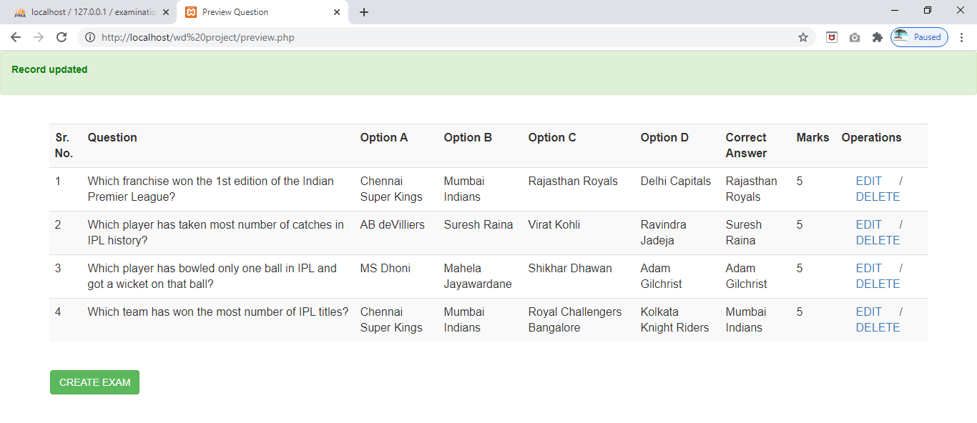

10. Instructor can delete a particular question by clicking the ‘DELETE’ button in the respective row. Before deleting the question, confirmation is taken from the instructor.

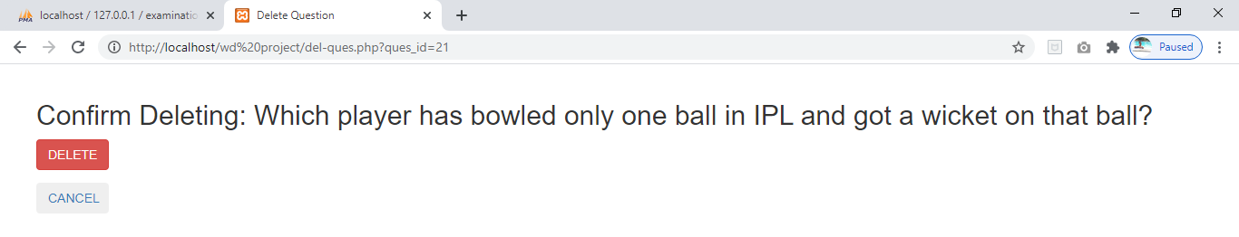

11. When a question is deleted successfully, the success message is displayed as shown below.

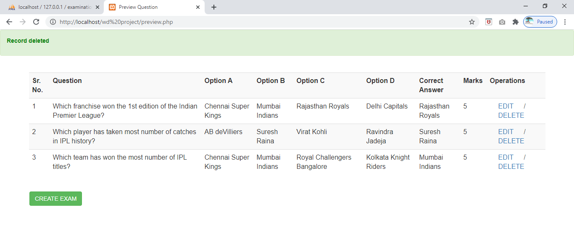

12. Below is an image displaying student log-in with correct username and password.

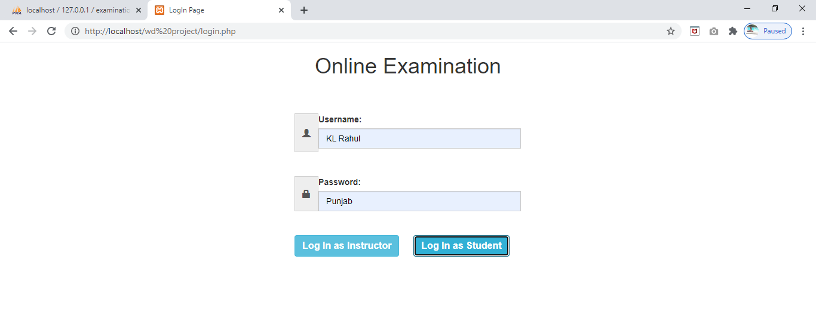

13. This is the student’s dashboard consisting of three different options:-

i. Take Exam

ii. View Result

iii. Logout

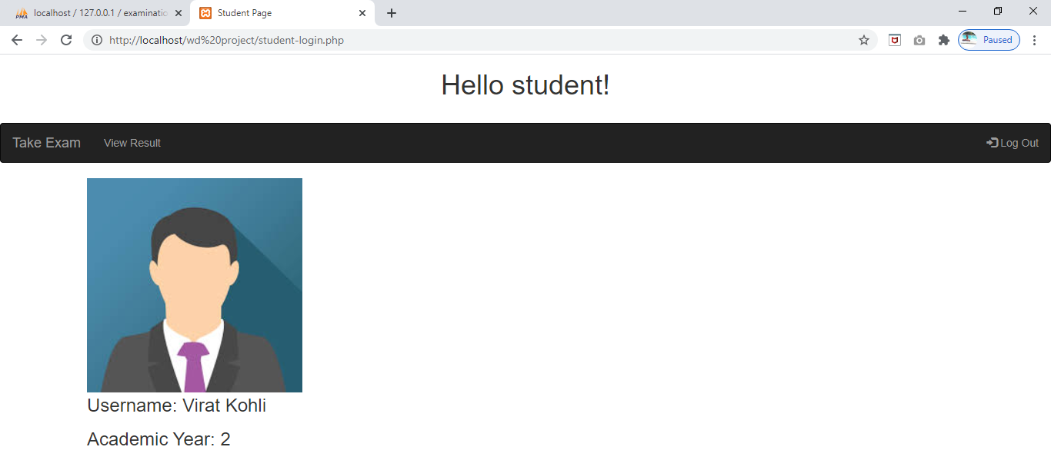

14. When student clicks on ‘Take Exam’ option, he is displayed the list of all the exams available to be taken.

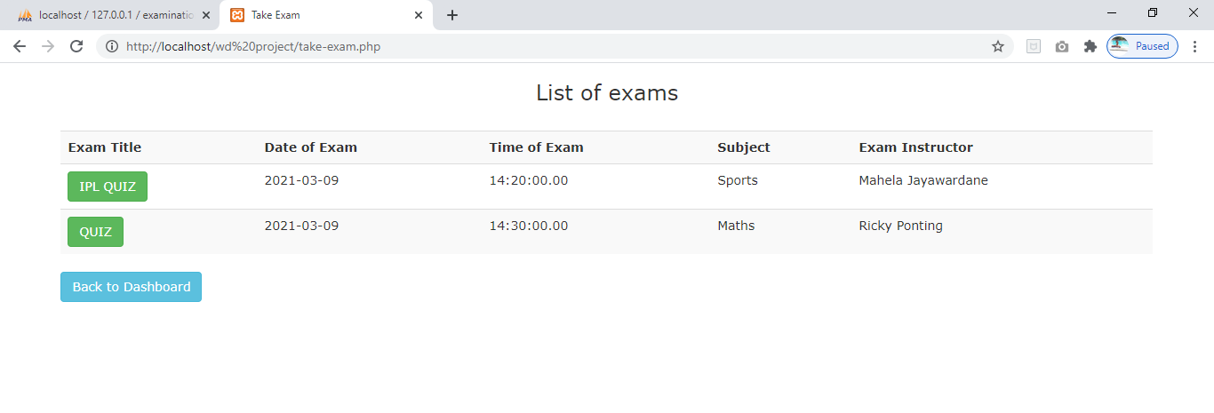

15. If the student opts to give an exam that has not yet started, then he is displayed an error message as shown below.

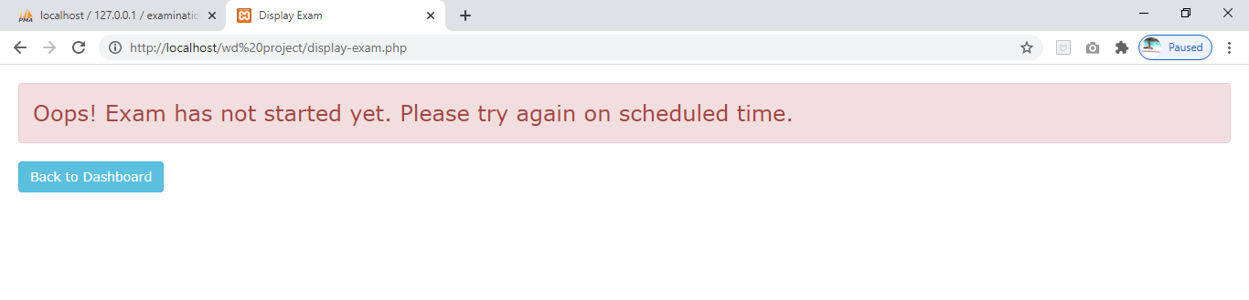

16. The entire exam is displayed as shown below. The user needs to submit the exam by clicking the ‘SUBMIT’ button. In case he doesn’t submit before the exam ends, it gets submitted automatically.

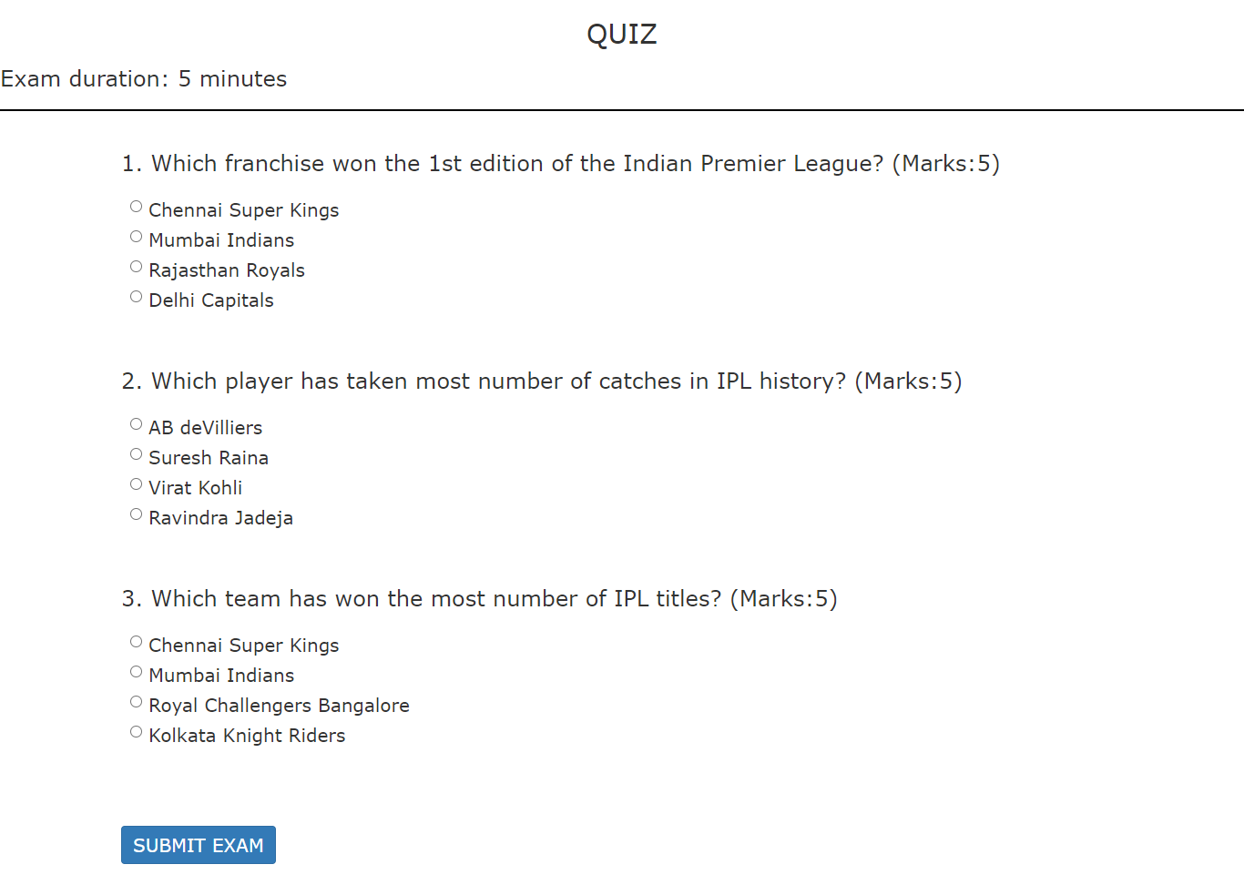

17. If the student is skillful enough to get all the answers correct, he will be displayed the marks with a ‘CONGRATULATIONS’ message, else only the marks will be displayed.

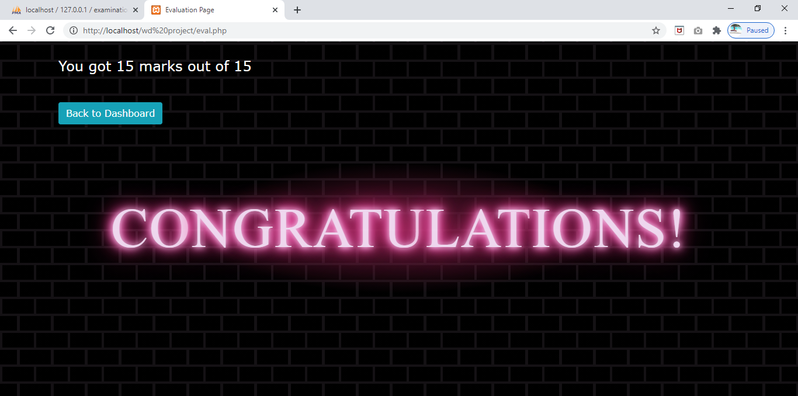

18. If a student tries to submit the exam for the second time, following message is displayed stopping them from duplicate submission.

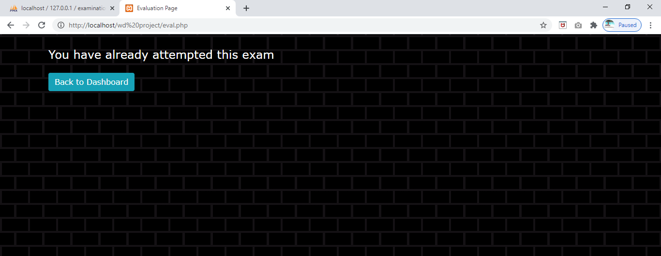

19. When an instructor wants to see the marks of students who have given an exam created by him/her, then they can click ‘View Results’ on the dashboard and the following having list of exams is created.

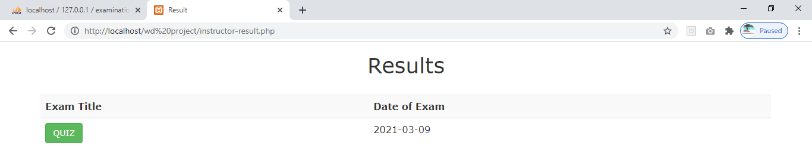

20. The marks of all the students who appeared for the exam selected by the instructor are displayed as shown in the image below.

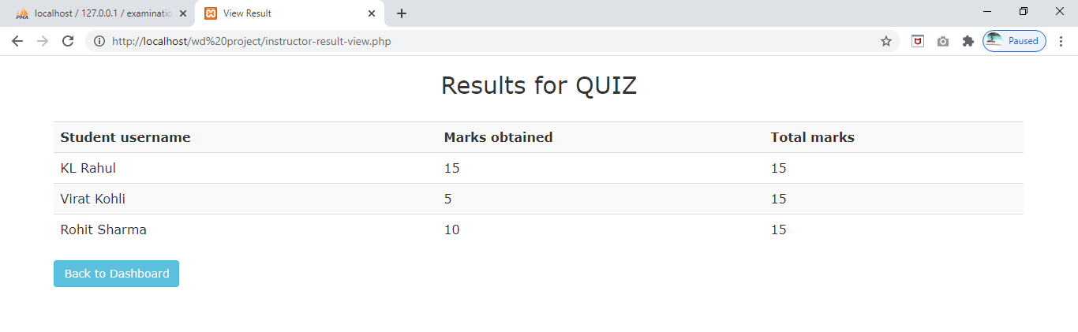

21. If a student wants to see the results of the exams he has attempted, then he/she can simply click on ‘View Results’ on the dashboard and the marks will displayed as shown below.

